React Responsive Ecommerce Website Tutorial
zainkeepscode

https://www.youtube.com/watch?v=P5VnLiGUmtY

Demo: https://amazon-3l2.pages.dev/
Project Amazon Starter :https://github.com/ZainRk/amazon-starterpack
Complete Source Code : https://www.patreon.com/zainkeepscode

Install "yarn"
> npm install --global yarn

Clone the starter package
> git clone https://github.com/ZainRk/amazon-starterpack

Go into the "Amazon Starterpack" folder and run yarn.
> yarn
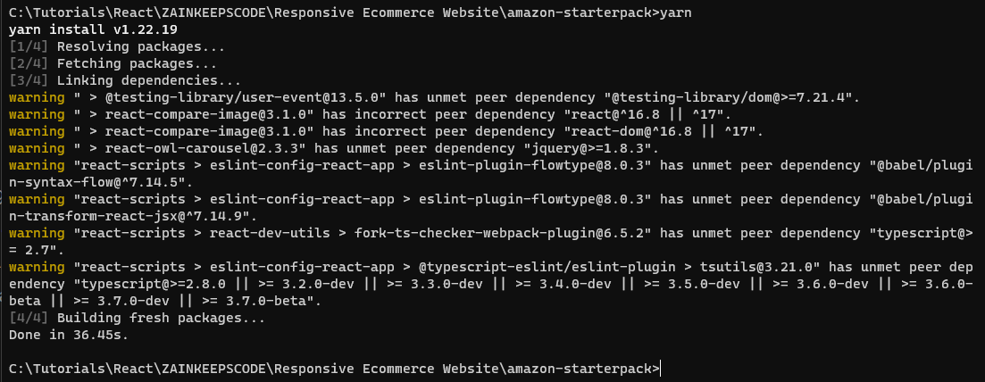
Start the server. (Currently runs on localhost:3000)
> yarn start

Open project with Visual Studio Code.
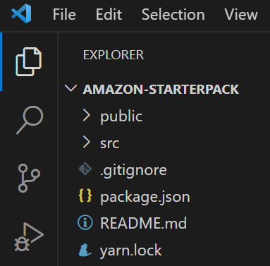

App.css defines some colors as color variables so we don't have to use hex codes.
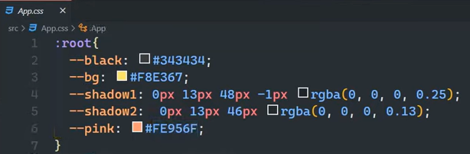

Create the Header
Create /Header.jsx file
Initialize it with "rafce"
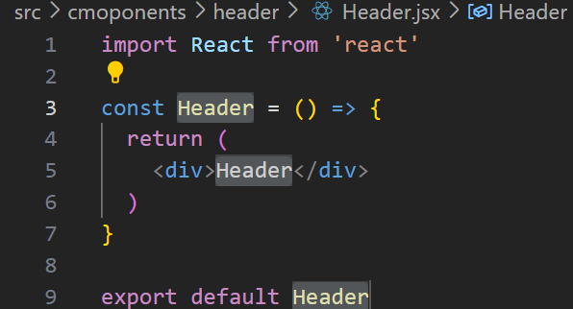
Replace App.jsx content with <Header/>

Create Header.module.css file and import it in the header.
Import css from './Header.module.css'

Shorthand for making divs:
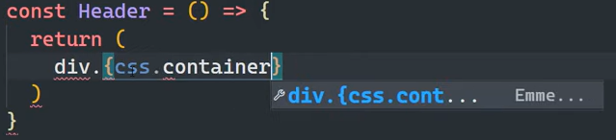
Creates:
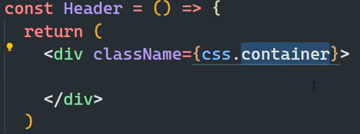
Shortcut works for all divs, such as <input>
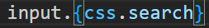
Creates:
